Mahmoud Essam

Introduction to Database

ID : 20221460231

ENG.Dina Elshebasy

Dr.Yasser Fouad

Simple design with code for Ibn-Elhaitham

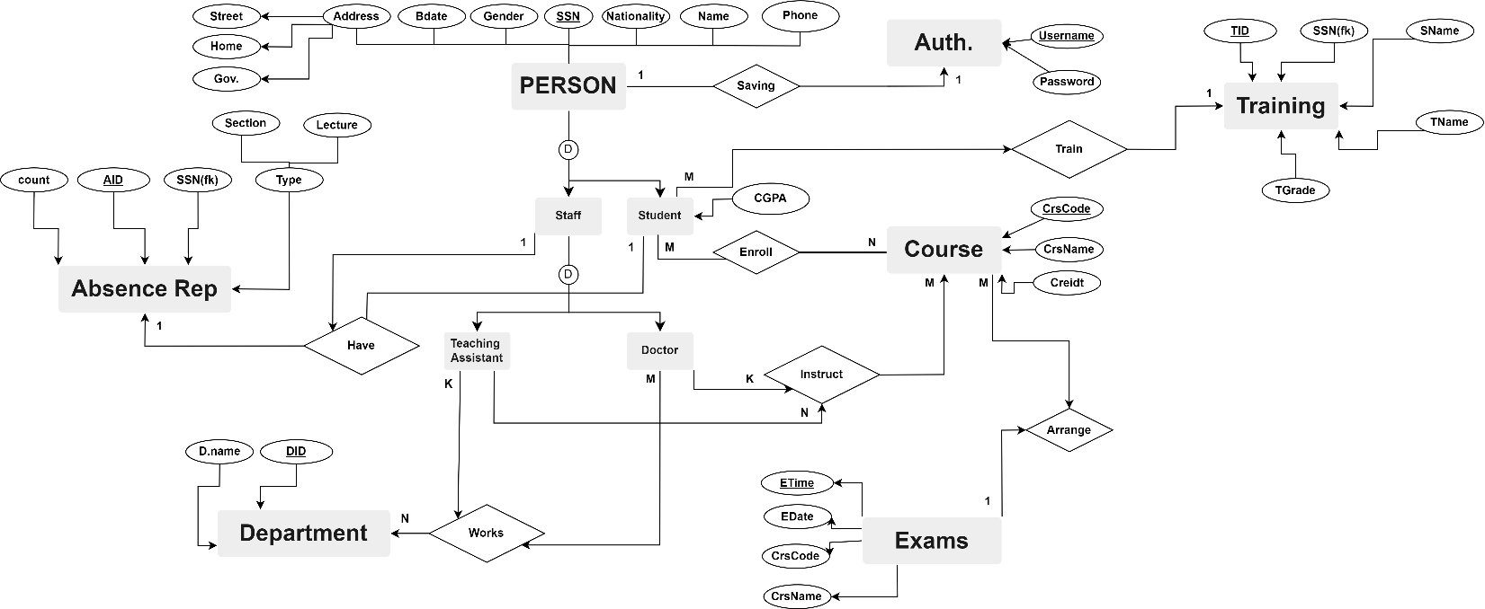



**________________________________________________________________________________________**

**Schema**

**Entities**

**Person (SSN, PName, PNationality, Pgender, PBdate, Pstreet, Phone, PGov)**

**Authentication (SSN, Username, Password)**

**#Using OO notation**

**Student (SSN, PName, PNationality, Pgender, PBdate, Pstreet, Phone, PGov, CGPA, TID)**

**Staff (SSN, PName, PNationality, Pgender, PBdate, Pstreet, Phone, PGov)**

**#Using ER notation**

**Doctor (SSN)**

**TA (SSN)**

**Department (DID, Dname)**

**Absence_Report (AID, SSN, Lecture, Section, count)**

**Course (CrsCode,CrsName,Credit)**

**Exams (Date,Time,CrsCode,CrsName)**

**Training(TID,SSN,PName,TName,TGrade)**

**Relations**

**Works_For(DID,SSN)**

**Enroll (SSN,CrsCode)**

**Instruct (SSN,CrsCode)**

**________________________________________________________________________________________**

**Normalize The Schema**

**(Entities)**

**Person (SSNpk, PName, PNationality, Pgender, PBdate, Pstreet, Phone, PGov) (1,2,3) NF achieved**

**Authentication (SSN, Username, Password) (1,2) NF achieved, 3 No, so will divide it**

**User_SSn (SSNfk, Usernamepk) (1,2,3) NF achieved**

**Authentication (Usernamepk,Password) (1,2,3) NF achieved**

**Student (SSNfk, CGPA, AIDfk, TIDfk) (1,2,3) NF achieved**

**Doctor (SSNfk) (1,2,3) NF achieved**

**TA (SSNfk) (1,2,3) NF achieved**

**Department (DIDpk, Dname) (1,2,3) NF achieved**

**Absence_Report (AIDpk, SSNfk, Lecture, Section, count) (1,2,3) NF achieved**

**Course (CrsCodepk, CrsName, Credit) (1,2,3) NF achieved**

**Exams (Date, Time, CrsCodefk, CrsNamefk) (1,2,3) NF achieved**

**Training (TIDfk, SSN, PName, TName, TGrade) (1,2,3) NF achieved**

**(Relations)**

**Works_For (DIDfk, SSNfk) (1,2,3) NF achieved**

**Enroll (SSNfk, CrsCodefk) (1,2,3) NF achieved**

**Instruct (SSNfk, CrsCodefk) (1,2,3) NF achieved**



















Step 1 :

Creation of tables to

Establish the Database





____________________________________________________________________________________________________________________________________________



________________________________________________________________________________________________________________________________________

**# Teaching Staff**

INSERT INTO PERSON VALUES

('20212120201834','Dr. Mahmoud','Egyptian','Male','12/12/2002','Muhammed Nagib','01277345867','Alexandria'),

(70211370402987,"Aisha Ali","Emirati","Female","04/02/1997","Sheikh Zayed Road","0501234567","Dubai");

INSERT INTO User_SSn(SSN,Username) VALUES(70211370402987,20301761098),(20212120201834,20301761097);

INSERT INTO Authentication (Username,Passwordofuser) VALUES (20301761098,"AishaAli123"),(20301761097,"drmahmoud");

INSERT INTO Absence_Report (AID,SSN,Lecture,Section,Counter) VALUES (107,70211370402987,"","",0),(80,20212120201834,"","",0);

INSERT INTO Doctor (SSN) VALUES (70211370402987),(20212120201834);

INSERT INTO Instruct (SSN,CrsCode) VALUES (70211370402987,"03-05-00123"),(20212120201834,"02-24-00109");

INSERT INTO Works_For(DID,SSN) VALUES(1,70211370402987),(1,20212120201834);

____________________________________________________________________________________________________________________________________________

**# TA Staff**

INSERT INTO person VALUES('30102015234567','Sarah Ahmed','Egyptian','Female','03/04/1995','Ahmed Mohamed','01001234567','Cairo');

INSERT INTO person VALUES('29122020111223','Hassan Ali','Egyptian','Male','01/02/2000','Ali Hassan','01112233445','Giza');

INSERT INTO person VALUES('03052008123456','Laila Mahmoud','Egyptian','Female','05/06/1988','Mahmoud Ahmed','01543210987','Luxor');

INSERT INTO User_SSn(SSN,Username) VALUES(30102015234567,20194567),(29122020111223,201901223),(3052008123456,20193456);

INSERT INTO Authentication (Username,Passwordofuser) VALUES (20194567,"TA1"),(201901223,"TA2"),(20193456,"TA3");

INSERT INTO Absence_Report (AID,SSN,Lecture,Section,Counter) VALUES (701,30102015234567,NULL,NULL,0),(702,29122020111223,NULL,NULL,0),(703,3052008123456,NULL,NULL,0);

INSERT INTO TA (SSN) VALUES (70211370402987),(20212120201834);

INSERT INTO Instruct (SSN,CrsCode) VALUES (30102015234567,"03-05-00123"),(29122020111223,"02-24-00109"),(3052008123456,"03-05-00123")

INSERT INTO Works_For(DID,SSN) VALUES(1,30102015234567),(1,29122020111223),(3,3052008123456)

____________________________________________________________________________________________________________________________________________

What about some specific questions with their answers?

# How will you distinguish between (Student-Doctor-TA)?

## Joins! We will use join to extract student then doctor then TA using People table, Code:

### SELECT * FROM Student as s JOIN Person as p ON s.SSN = p.SSN “For Student”

|  |  |  |  |  |  |  |  |  |  |  |  |
| --- | --- | --- | --- | --- | --- | --- | --- | --- | --- | --- | --- |
| SSN | CGPA | AID | TID | SSN | PName | PNationality | Pgender | PBdate | Pstreet | Phone | PGov |
| 30212120201834 | 3.69 | 1 | 1 | 30212120201834 | Mahmoud Essam | Egyptian | Male | 12/12/2002 | Muhammed Nagib | 01277345866 | Alexandria |
| 9876543210 | 3.25 | 3 | 2 | 9876543210 | John Doe | American | Male | 1995-03-15 | 123 Main St | 555-123-4567 | New York |
| 1234567890 | 3.9 | 5 | 4 | 1234567890 | Jane Smith | Canadian | Female | 1998-08-21 | 456 Oak St | 555-555-5555 | Toronto |
| 4561237890 | 3.5 | 7 | 6 | 4561237890 | Maria Rodriguez | Spanish | Female | 2001-04-01 | 789 Maple St | 555-123-7890 | Madrid |

### SELECT * FROM Doctor as d JOIN Person as p ON d.SSN = p.SSN “For Doctors”

|  |  |  |  |  |  |  |  |  |
| --- | --- | --- | --- | --- | --- | --- | --- | --- |
| SSN | SSN | PName | PNationality | Pgender | PBdate | Pstreet | Phone | PGov |
| 70211370402987 | 70211370402987 | Aisha Ali | Emirati | Female | 04/02/1997 | Sheikh Zayed Road | 0501234567 | Dubai |
| 20212120201834 | 20212120201834 | Dr.Mahmoud | Egyptian | Male | 12/12/2002 | Muhammed Nagib | 01277345867 | Alexandria |

### SELECT * FROM TA as t JOIN Person as p ON t.SSN = p.SSN “For Teaching Assistant”

|  |  |  |  |  |  |  |  |  |
| --- | --- | --- | --- | --- | --- | --- | --- | --- |
| SSN | SSN | PName | PNationality | Pgender | PBdate | Pstreet | Phone | PGov |
| 30102015234567 | 30102015234567 | Sarah Ahmed | Egyptian | Female | 03/04/1995 | Ahmed Mohamed | 01001234567 | Cairo |
| 29122020111223 | 29122020111223 | Hassan Ali | Egyptian | Male | 01/02/2000 | Ali Hassan | 01112233445 | Giza |
| 3052008123456 | 3052008123456 | Laila Mahmoud | Egyptian | Female | 05/06/1988 | Mahmoud Ahmed | 01543210987 | Luxor |

# What about courses that student enrolling?

## Another join for student! , so we will get student table and enroll it and retrieve the course:

## SELECT s.SSN,e.CrsCode,c.CrsName;

## FROM Student as s

## JOIN Enroll as e ON s.SSN = e.SSN

## JOIN Course as c ON e.CrsCode = c.CrsCode

|  |  |  |
| --- | --- | --- |
| SSN | CrsCode | CrsName |
| 30212120201834 | 02-24-00109 | Machine Learning |
| 9876543210 | 01-01-01001 | Web Development |
| 1234567890 | 03-12-00201 | Data Structures |
| 4561237890 | 02-18-00101 | Artificial Intelligence |

# how would I know the number of students enrolled in specific training?

## Let’s try some aggregation functions like Count!

## SELECT count(*) as Number_of_students_in_iti FROM Training where Training.TName="ITI"

|  |
| --- |
| **Number_of_students_in_iti** |
| 2 |

# can I know the login system for every person?

## Joins! We will use join to extract student then doctor then TA using People table, Code:

### SELECT us.SSN,a.Username,a.Passwordofuser FROM User_SSn as us JOIN Authentication as a ON us.Username = a.Username JOIN Doctor as d ON us.SSN = d.SSN

|  |  |  |
| --- | --- | --- |
| SSN | Username | Passwordofuser |
| 70211370402987 | **20301761098** | **AishaAli123** |
| 20212120201834 | **20301761097** | **drmahmoud** |

### SELECT us.SSN,a.Username,a.Passwordofuser FROM User_SSn as us JOIN Authentication as a ON us.Username = a.Username JOIN Student as s ON us.SSN = S.SSN

|  |  |  |
| --- | --- | --- |
| SSN | Username | Passwordofuser |
| 30212120201834 | 20221460231 | Mahmoud7 |
| 9876543210 | johndoe95 | password123 |
| 1234567890 | janesmith98 | password456 |
| 4561237890 | mariarodriguez01 | pass1234 |

### SELECT us.SSN,a.Username,a.Passwordofuser FROM User_SSn as us JOIN Authentication as a ON us.Username = a.Username JOIN TA as t ON us.SSN = T.SSN

|  |  |  |
| --- | --- | --- |
| SSN | Username | Passwordofuser |
| 30102015234567 | 20194567 | TA1 |
| 29122020111223 | 201901223 | TA2 |
| 3052008123456 | 20193456 | TA3 |

# can I know number of doctors and TA working in data science department?

## Let’s perform it!

### SELECT d.ssn,w.DID,p.pname FROM Doctor as d JOIN Works_For as w ON d.ssn = w.ssn JOIN Person as p ON d.ssn = p.ssn WHERE w.DID = 1

|  |  |  |
| --- | --- | --- |
| SSN | DID | PName |
| 70211370402987 | 1 | Aisha Ali |
| 20212120201834 | 1 | Dr.Mahmoud |

### SELECT t.ssn,w.DID,p.pname FROM TA as t JOIN Works_For as w ON t.ssn = w.ssn JOIN Person as p ON t.ssn = p.ssn where w.DID = 1

|  |  |  |
| --- | --- | --- |
| SSN | DID | PName |
| 30102015234567 | 1 | Sarah Ahmed |
| 29122020111223 | 1 | Hassan Ali |

Last thing : retrieve all students where their CGPA greater than 3.5 with their names :

|  |  |  |
| --- | --- | --- |
| SSN | CGPA | PName |
| 30212120201834 | 3.69 | Mahmoud Essam |
| 1234567890 | 3.9 | Jane Smith |

SELECT s.SSN,s.CGPA ,p.PName

from Student as s JOIN Person as p ON s.ssn = p.ssn